Design Doc Template

*Author(s): xyz*

*Date: 22/05/2019*

Revision: 0

Document Status: Draft [Draft, Completed, Submitted, Reviewed, Final]

Project Status: In-Progress [In Review, Approved, In-Progress, Completed]

Revision History

|  |  |  |  |
| --- | --- | --- | --- |
| Date | Revision | Description | Author |
| 22/05/2019 | 0 | Initial draft of the design doc template | xyz |
|  |  |  |  |
|  |  |  |  |
|  |  |  |  |
|  |  |  |  |
|  |  |  |  |
|  |  |  |  |
|  |  |  |  |
|  |  |  |  |
|  |  |  |  |

Table of Contents

TOC \o "1-3" \h \z \u Introduction4

Summary4

Background4

Definitions, Acronyms, and Abbreviations4

Design Overview4

Requirements4

Documentation4

Minimum Viable Product5

Stretch goals5

Future work5

Architectural Diagrams5

System Diagrams5

Application Programming Interface5

Recommendations5

User Interface6

Data Models and Storage6

Service Operability6

Key Performance Indicators6

Service Level Objectives6

Project Overview7

Communication and Tracking7

Risks7

Milestones7

Project Phases7

Cost7

Frequently Asked Question7

References7

Addendum8

# Introduction

## Summary:

Our main idea use to save the crop from the animals which come to damage the crops

## Background

Detecting the animals entering into the crop and producing the sound irritates the respective animals.so that it will move out of the crop

We are trying to solve the problem of crop damage. Presently farmer are using the electrical fencing , drum sound , light inside red pot etc…

Electrical fencing will cause electric shock to the animals the animals will die. Drum sound require lot of human effort

Our solution is unique because it does not required any human effort and animals will not get harm by using this.

## Definitions, Acronyms, and Abbreviations

Definition: To protect the crops and save the animals by this method it’s fears the animal with negative sound.

Abbreviation: To secure the crop

## Requirements

A device which protect the crop

1)LASAR

2) LIGHT DEPENDENT RESISTOR SENSOR (LDR)

3) MIRROR ( for reflecting )

4)POLES (as require)

5)SD MODULE (NEGETIVE SOUND PRODUCE)

6)GSM MODULE (USING FOR NOTIFICATION)

7)ARDINO BOARD (UNO)

8) Bluetooth Receiver

### Documentation

If the project requires any wiki pages, code comments, presentations, etc. that information should be

## Minimum Viable Product

A detailed description of the deliverable for this project, this is the minimal functionality required for the project to be considered successful and should not include stretch goals or future work.

## Stretch goals

Stretch goals include functionality beyond the scope of the minimum viable product that should be include in the project should time and budget permit. Unlike future work, stretch goals would be smaller tasks for features in support of the minimum viable product.

## Future work

This may include ongoing support, expansion of the original scope, work that requires transitions in project ownership, or details of projects designed to be broken up into multiple phases.

# Architectural Diagram

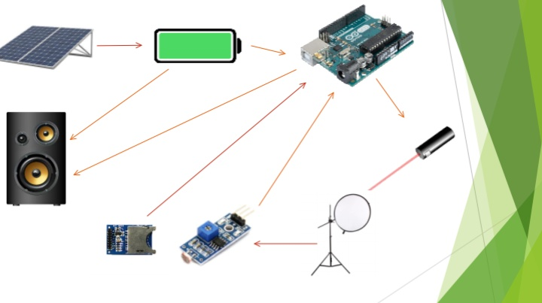

# System Diagrams

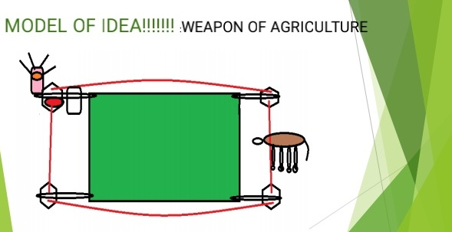

# Application Programming Interface

To secure for crop

Farmer to refreshment by listening songs based on design

## Recommendations

/api/v0

# User Interface

There is no interface in our product

# Data Models and Storage

For projects requiring messages queue such as Kafka, MySQL, etc.

Kafka

* How many partitions are needed for this topic?
* How many days of retention will be needed?
* What will the partitioning key become?
* How much data will be written to the topic during peak hours?
* What type of Kafka cluster will be needed? (E.g. aggregate, queuing, tracking, metrics, logging)

MySQL

* What does the table schema look like and how are they all tied together (provide a UML)?
* What sort of updates will be made to the tables?
* How will users make queries to the tables? (e.g. Complex joins, pre-filtering, single record gets)
* What the strategy for indexing?

# Service Operability

## Key Performance Indicators

Key performance indicators (KPI), describe how a service should be monitored and how its performance can be gauged. This would typically include an overview of the types of metrics an application will need to emit, call time, error rate, etc.

## Service Level Objectives

Service level objectives (SLOs), set targets for various KPI through alerts via email or SMS, these targets may provide early indicators of approaching a capacity limit, changes in load patterns through various phases of an application, changes in duration of offline processing, etc.

# Project Overview

## Communication and Tracking

To secure the crops

## Risks

Animal get irritate by negative sound and it will away from the crop

## Milestones

week 1:

We shown the prototype design in 3sq.ft

Week 2:

We use one acre in jhub land we will shown the design

Week 3:

We will go to village

Choose the form (2 acre)

We use to design our product

Its verify by the farmer

Week 4:

As we done in previous week .we take the video clip and shown to the mentors in jhub

Week 5 :

We will approve to the Government .

Week 6 :

Finally we advertise our product

project Phases

where the problem I faced !!!!

I got idea about crop safety by the animals. Because my form got damaged by the animals

I chosen title as ( WEAPON OF AGRICULTURE )

By using our product .This weapon will give the fear when animal entered into crop

Based on our product laser act as fencing line.

When the laser break LDR module detects and it gives the negative sounds

We have a additional advantage Bluetooth option to listen the songs will working in farm

## Cost

Level of effort, number of resources, number of hours or weeks, unlike milestones which tracks project time cost should only include engaged time.

1) For the all tasks which are deliverables/visible on user-end side needs to be documented as stories.

2) Need to guess/estimate the time required in number of hours for the completing that stories which can be captured in taiga.

3) Assign that task to the right person and document the actual time taken for completing that task.

# Frequently Asked Question

# References

Links to any supporting documentation, other projects, or reference material

# Addendum

Additional diagrams or details that do not particularly belong in the body of the design doc. This could also be a place to describe additional examples that would otherwise bloat the introduction section. More specifics on APIs could also be placed here for engineers to reference.